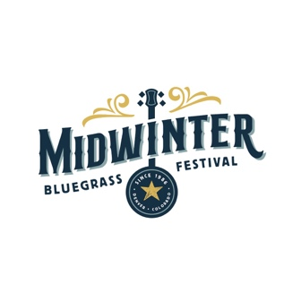

Midwinter Bluegrass Festival Order Form
February 16-19, 2023
Delta by Marriott (formerly the Radisson)
10 E 120th Ave, Northglenn, CO 80233

NAME:

ADDRESS:

Ticket | Cost | How Many? | Subtotal
3 Day Pass | $105
Fri/Sat 2 Day Pass | $90
Sat/Sun 2 Day Pass | $90
Friday Only | $55
Saturday Only | $70
Sunday Only | $55
3 Day, Child 6-12 | $45
Fri/Sat 2 Day, Child 6-12 | $30
Sat/Sun 2 Day, Child 6-12 | $35
1 Day, Child 6-12, specify which day | $25
 | Totals:

Tickets/Wristbands will be held at Will Call, Check In Table

Mail form and check to:
Ryegrass Productions, LLC
1332 N Cascade Ave
Colorado Springs, CO 80903

